NC Math 3 Honors - Unit 7 Trigonometry Review

- On your test, you will be given a partially completed unit circle. (Not just the 1st quadrant.) You will need to fill in all missing information (angle measures in degrees and radians and ordered pairs).

- Fill in any missing values in the table below:
$$x$$ | $$sin x$$ | $$cos x$$ | $$tan x$$ | $$sec x$$ | $$csc x$$ | $$cot x$$
$$\frac{10π}{3}$$
$${-135}^{0}$$
$$-\frac{3π}{2}$$
$${330}^{0}$$

- Identify the period and amplitude of each of the following. Then graph the function.
  - $y=-\frac{1}{2}\cos\left(2x\right)-4$
  - $y=3\sin{x}+5$

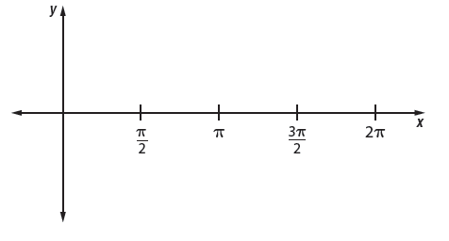

- Write an equation for each of the following graphs.
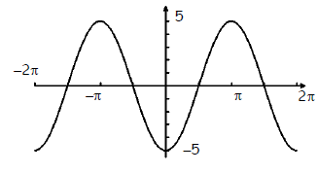
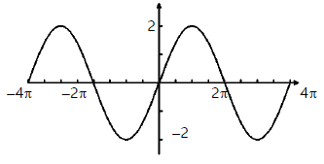

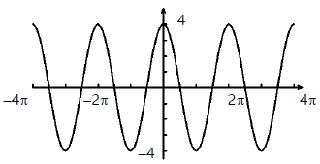
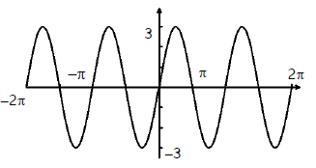

- You have probably noticed that when you ride a Ferris Wheel, the distance from the ground varies sinusoidally with time. When the last seat is filled and the Ferris wheel starts, your seat is at the position in the figure below. Let t be the number of seconds that have elapsed since the Ferris wheel started. You find that it takes you fourteen seconds to reach the top, 35 feet above the ground, and that the wheel makes a revolution every eight seconds. The diameter of the wheel is 30 feet.
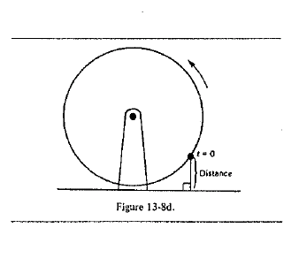
- Write an equation to model this situation.

- Identify the period of the function and the amplitude.

- Predict the height above the ground when: t = 6, t = 9, and t =0.

6. BA buoy bobbing up and down in the water as waves passes, it moves from its highest point to its lowest point, and back to its highest point every 10 seconds. The distance between the highest and lowest points is three feet.

- Determine the amplitude and period of sinusoidal function that models the bobbing buoy.

- Write an equation of a sinusoidal function that models the bobbing buoy, using x = 0 as its highest point.

- Find the height of the buoy after 15 seconds.

Identify the center and radius for each circle:

- ${(x+1)}^{2}+{(y-6)}^{2}=3$

- ${(x-5)}^{2}+{(y+6)}^{2}=16$
- $x^{2}+24x+y^{2}+10y+160$

- $x^{2}-6x+y^{2}-32y=-264$

Write the equation of a circle with the given information:

- Center $(-5, -8)$ and radius 2
- Center $(-13, -16)$ through $(-10,-1$

Convert each angle from radians to degrees:

- $\frac{π}{4} radians$
- $\frac{-13π}{3} radians$
- $\frac{47π}{6} radians$

Convert each angle from degrees to radians:

- ${420}^{0}$
- ${-20}^{0}$
- ${225}^{0}$

For each of the following:
- Sketch the angle in standard position.
- Determine one positive and one negative coterminal angle.

- $-{150}^{0}$
- ${45}^{0}$
- ${510}^{0}$
- $\frac{3π}{4}$ radians
- $-\frac{10π}{3}$ radians
- $\frac{17π}{6}$ radians

Use the given information to determine each of the six trigonometric ratios:

- $\tan{θ}=\frac{8}{15}$
- $\csc{θ=}$ $\frac{12}{5}$

Fill in the blank unit circle below. Make sure to include angles in both degrees and radians.
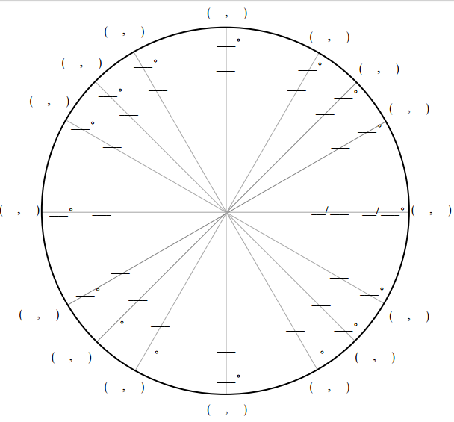

Use the unit circle to determine the value of each trigonometric ratio below:

- $\sin\left(\frac{π}{4}\right)$
- $\tan\left(-\frac{3π}{2}\right)$
- $\cos\left(\frac{π}{6}\right)$
- $\csc\left(\frac{4π}{3}\right)$
- $\sec\left(\frac{11π}{6}\right)$
- $\sin\left(-{60}^{0}\right)$
- $\cot\left({270}^{0}\right)$
- $-\cos\left({150}^{0}\right)$
- $\sec\left({315}^{0}\right)$

