Dilations and Similarity
Properties of Dilation Investigation
Dilate $∆ABC$ about the origin with a magnitude of 2. Graph the new triangle; label the vertices $A^{'}, B^{'}, \& C'$.

A
B
C

Complete the following using your dilation.
- Compare the angles of $∆ABC$ and $∆A'B'C'$. What do you notice?

- Using a ruler, find the lengths of $\overline{AB}, \overline{A^{'}B^{'}}, \overline{AC}, \overline{A^{'}C^{'}}, \overline{BC},$ and $\overline{B^{'}C^{'}}$. What do you notice?

- Dilations create similar figures. Based on your observations from 1 and 2, what can we say about similar figures?

- What do you notice about the placement of segments $\overline{AB}$ and $\overline{A^{'}B^{'}}$ on the coordinate plane? $\overline{AC}$ and $\overline{A^{'}C^{'}}$? Note that $A$ and $A'$ lie on the origin. What conclusion can you make about the segments of an image when the corresponding segments of the preimage pass through the center of dilation?

- Compare the slopes of $BC$ and$\overline{B^{'}C^{'}}$. What does that tell you about the relationship of the lines to one another? What conclusion can you make about the segments of an image when the corresponding segments of the preimage do not pass through the center of dilation?

Checkpoint:
When a line segment passes through the center of dilation, the line segment and its image lie on the _________ __________.
When a line segment does not pass through the center of dilation, the line segment and its image are ____________.
Dilations create figures that are always _________________ to one another.
Two figures are similar (~) if they have the same ______________ but not necessarily the same ____________.

The ________________ __________________ is the ratio of the lengths of the corresponding sides.
(a.k.a. the ________________ __________________)
Two figures are congruent 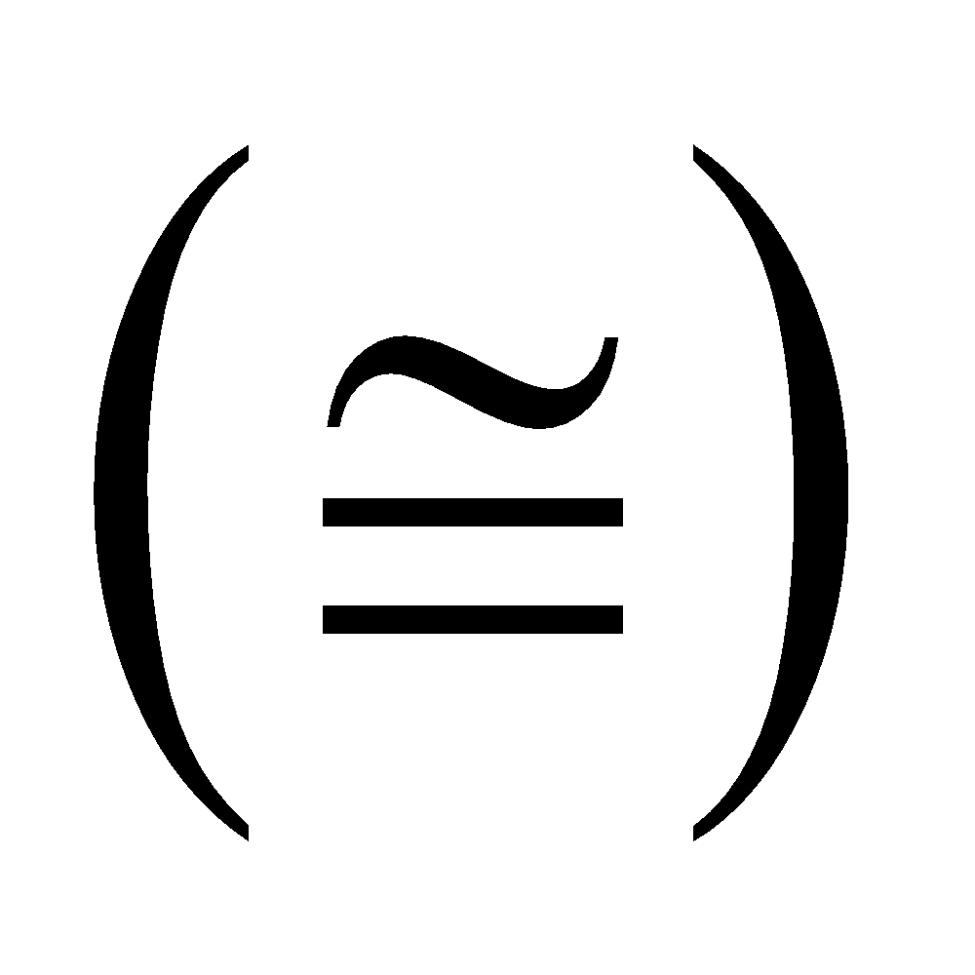 if they are similar and ______________________________________.
Two polygons are similar if:
1) Corresponding _______ are ____________ AND 2) Corresponding ________ are ____________
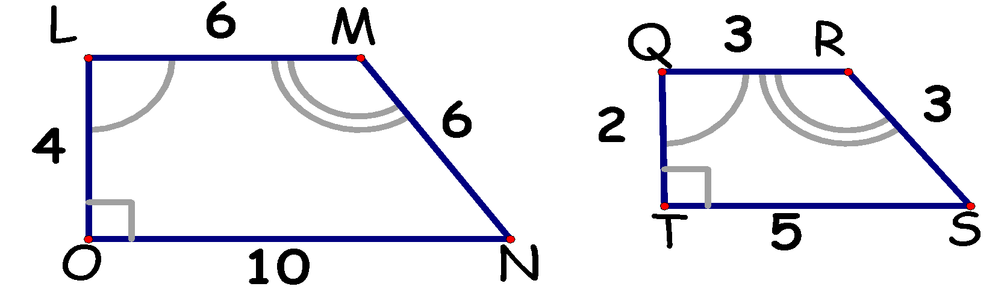

Checkpoint:
When a line segment passes through the center of dilation, the line segment and its image lie on the _________ __________.
When a line segment does not pass through the center of dilation, the line segment and its image are ____________.
Dilations create figures that are always _________________ to one another.
Two figures are similar (~) if they have the same ______________ but not necessarily the same ____________.

The ________________ __________________ is the ratio of the lengths of the corresponding sides.
(a.k.a. the ________________ __________________)
Two figures are congruent if they are similar and ______________________________________.
Two polygons are similar if:
1) Corresponding _______ are ____________ AND 2) Corresponding ________ are ____________

