Name: __________________________

FACTORING PRACTICE

Directions: Factor the following quadratics.

- $x^{2}+3x+2$ = ( )( )

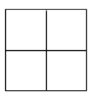

- $a^{2}-2a-35$ = ( )( )

- $3x^{2}-8x+4$ = ( )( )

- $2w^{2}+12w-14$ = ( )( )

- ${2p}^{2}-24p+54$ = ( )( )

- $2b^{2}-18b+40$ = ( )( )

